Test Case: tc002_SPX_Dev5_Crear_Requisicion_Spot_Tipo_Cobro_Project
Step 1 - Enter username and password and click to button Enter: Credentials Entered
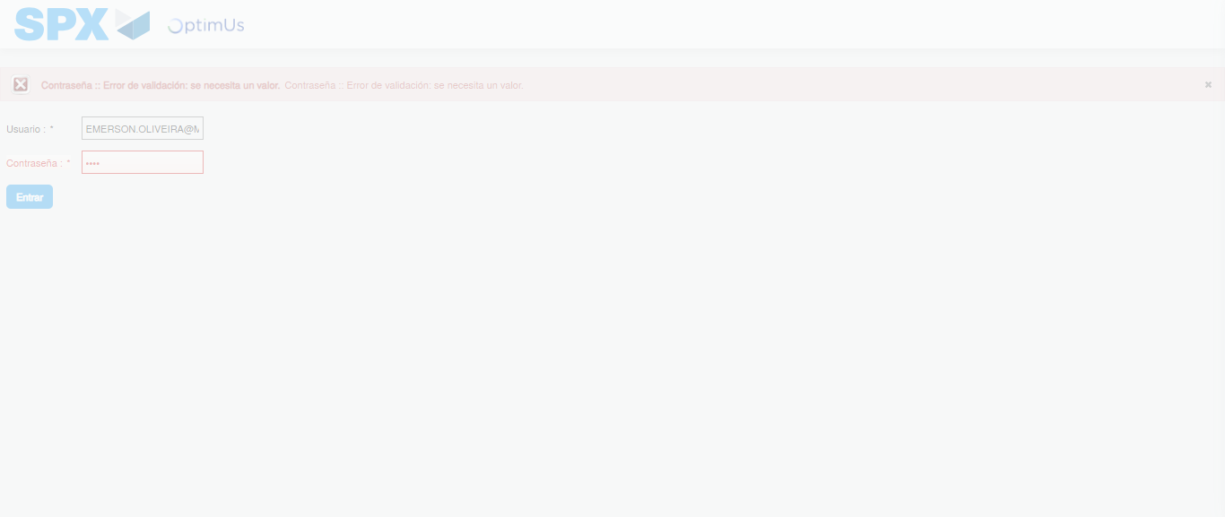Image file-name: QC_Testing-tc002_SPX_Dev5_Crear_Requisicion_Spot_Tipo_Cobro_Project-1784232963373

Step 2 - Select to UEN and Access to Spot Buy Requisitions : UEN Correctly selected and Correct access
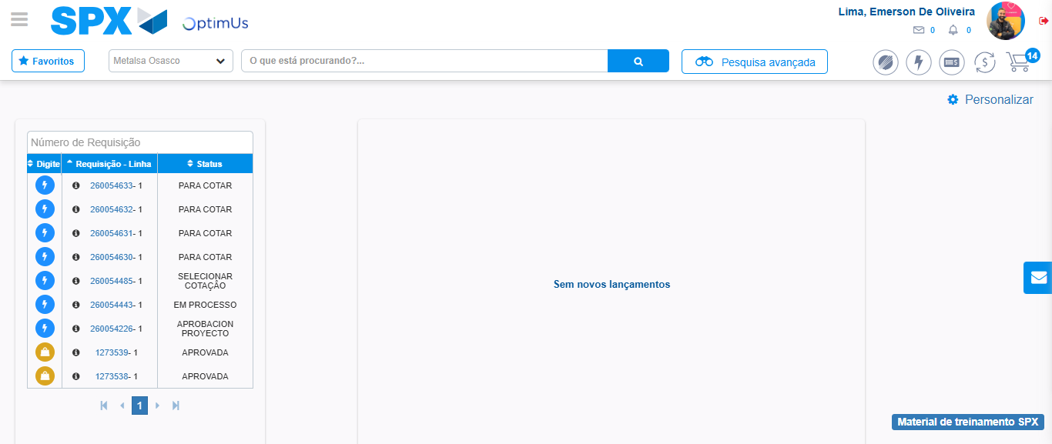Image file-name: QC_Testing-tc002_SPX_Dev5_Crear_Requisicion_Spot_Tipo_Cobro_Project-1784233040203

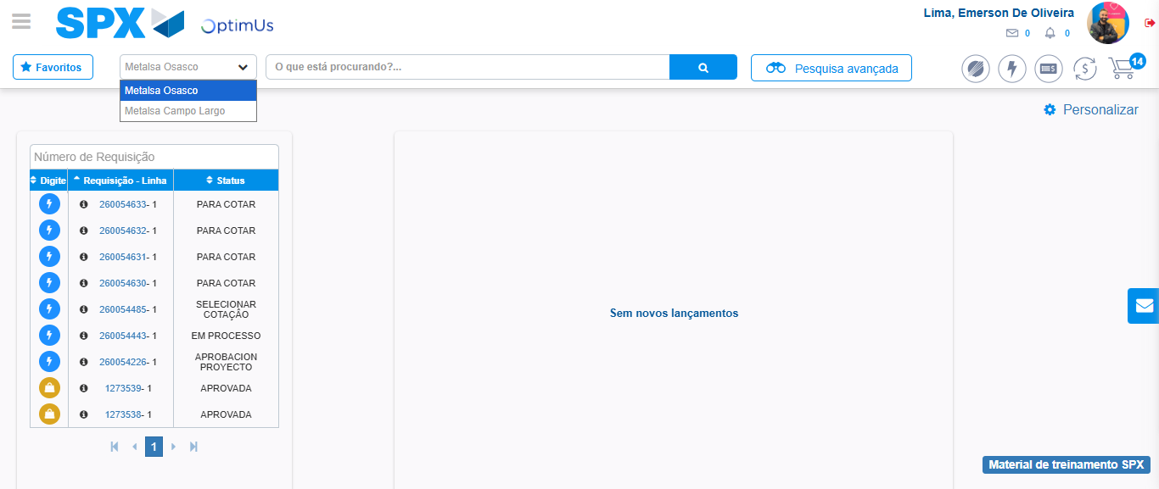Image file-name: QC_Testing-tc002_SPX_Dev5_Crear_Requisicion_Spot_Tipo_Cobro_Project-1784233042773

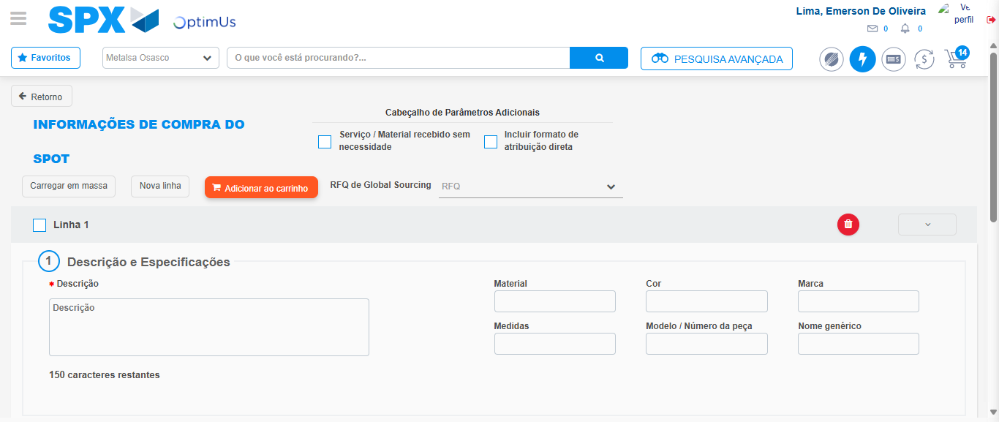Image file-name: QC_Testing-tc002_SPX_Dev5_Crear_Requisicion_Spot_Tipo_Cobro_Project-1784233048032

Step 3 - Data Capture Spot Buy Requisition: Data captured correctly
Image file-name: QC_Testing-tc002_SPX_Dev5_Crear_Requisicion_Spot_Tipo_Cobro_Project-1784233048310

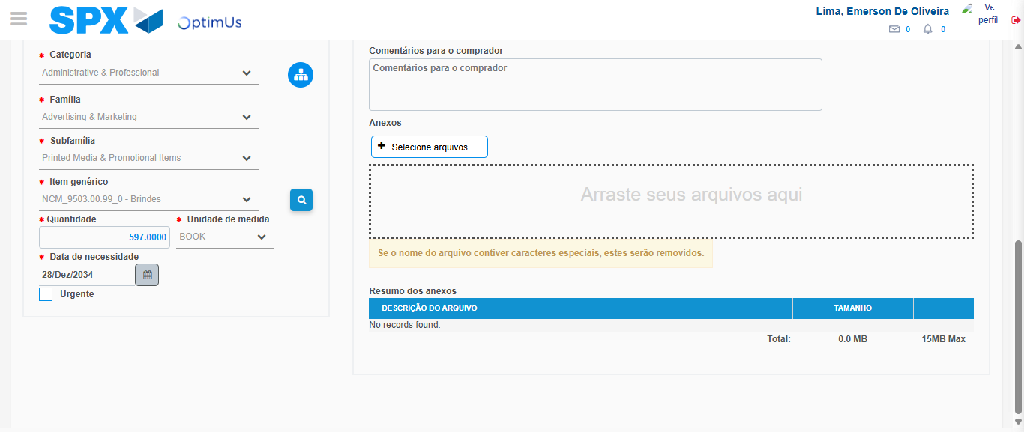Image file-name: QC_Testing-tc002_SPX_Dev5_Crear_Requisicion_Spot_Tipo_Cobro_Project-1784233061300

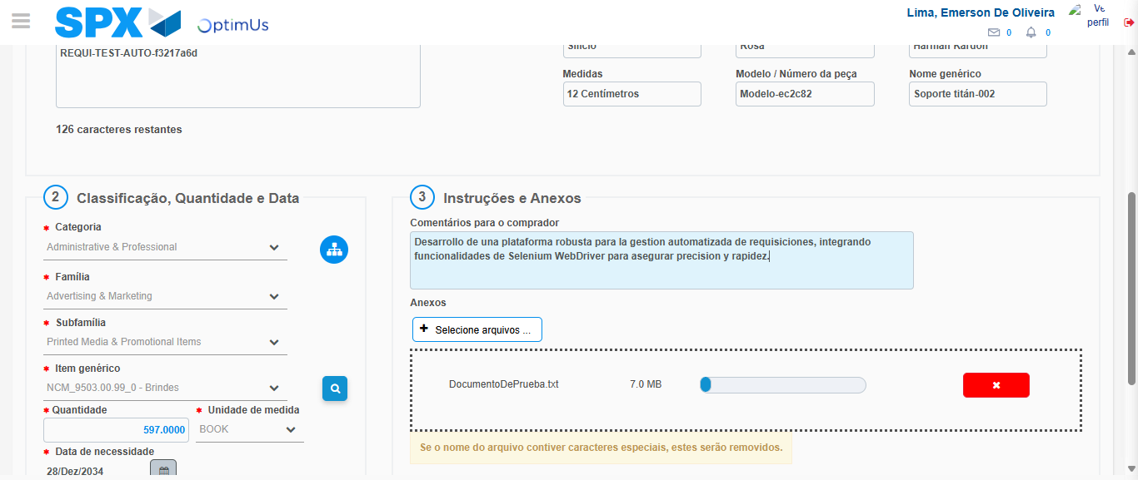Image file-name: QC_Testing-tc002_SPX_Dev5_Crear_Requisicion_Spot_Tipo_Cobro_Project-1784233062368

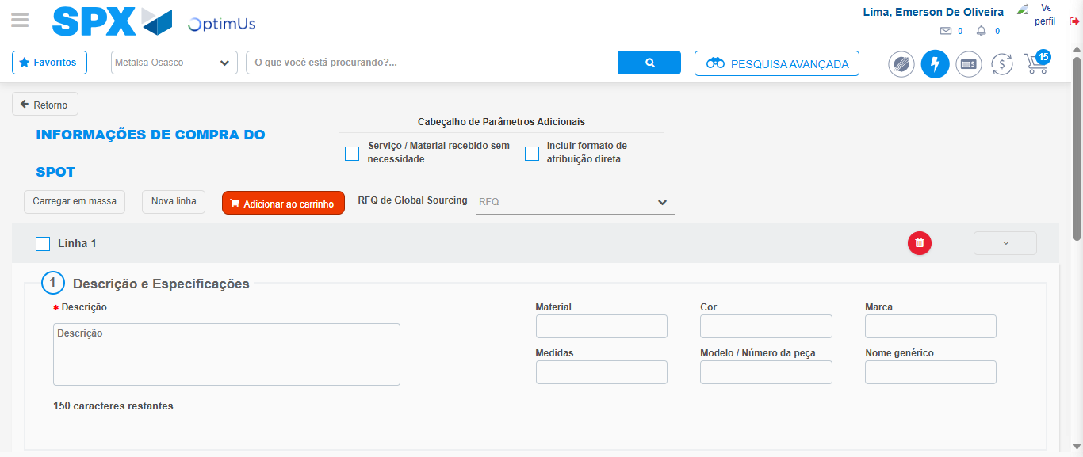Image file-name: QC_Testing-tc002_SPX_Dev5_Crear_Requisicion_Spot_Tipo_Cobro_Project-1784233066414

Step 7 - Return to Main Page SPX : Return to Main Page SPX
Image file-name: QC_Testing-tc002_SPX_Dev5_Crear_Requisicion_Spot_Tipo_Cobro_Project-1784233040203

Image file-name: QC_Testing-tc002_SPX_Dev5_Crear_Requisicion_Spot_Tipo_Cobro_Project-1784233042773

Image file-name: QC_Testing-tc002_SPX_Dev5_Crear_Requisicion_Spot_Tipo_Cobro_Project-1784233048032

Image file-name: QC_Testing-tc002_SPX_Dev5_Crear_Requisicion_Spot_Tipo_Cobro_Project-1784233068723

Image file-name: QC_Testing-tc002_SPX_Dev5_Crear_Requisicion_Spot_Tipo_Cobro_Project-1784233068901

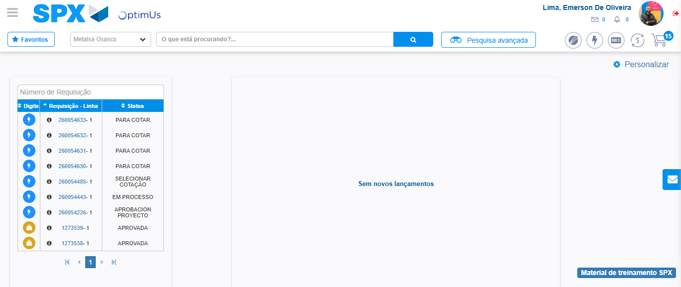Image file-name: QC_Testing-tc002_SPX_Dev5_Crear_Requisicion_Spot_Tipo_Cobro_Project-1784233089984

Step 8 - Log Out : Log Out SPX
Image file-name: QC_Testing-tc002_SPX_Dev5_Crear_Requisicion_Spot_Tipo_Cobro_Project-1784233090194

